The Roger and Susan Hertog Center for the Archaeological Study of Jerusalem and Judah-202**4**

The Hertog Center has made M.A., Ph.D. and Post Doc scholarships available for excellent students who will pursue in the Institute of Archaeology at the Hebrew University of Jerusalem, cutting-edge research on a range of topics related to the archaeology of Jerusalem and Judah throughout the ages.

The M.A. scholarship recipient will be awarded $20,00 per year for two years (beginning October 2023).

The Ph.D. scholarship recipient will be awarded $27,00 per year for up to four years (beginning October 2023).

The Postdoctoral scholarship recipient will be awarded $40,500 per year for one year (October 2023–September 2024) and is open to scholars who have received or have approval of their Ph.D. within the last three years before the scholarship commences.

**Application deadline:  29.3.2023**

**The submission is made by the submitter’s approval at the end**

Application procedure

**1.** **Fill out the**[**online application form.**](https://scholarships2.ekmd.huji.ac.il/home/humanities/HUM188-2021/Pages/Form.aspx)

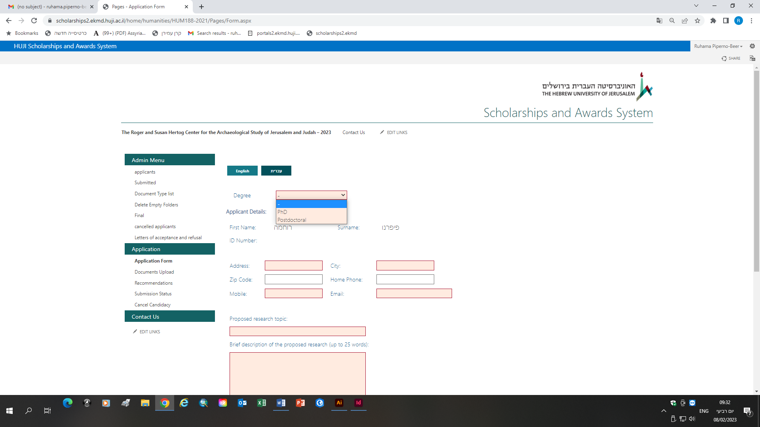

M.A. להוסיף

**2.** **Upload the following documents via the**[**Documents Upload page**](https://scholarships2.ekmd.huji.ac.il/home/humanities/HUM188-2021/Pages/DocumentsUpload.aspx)

**להוסיף**

**For M.A. scholarships**

* Curriculum vitae
* B.A. transcripts
* A short description on the intended subject of research (2 pages)
* Declaration of additional funding received for the Ph.D